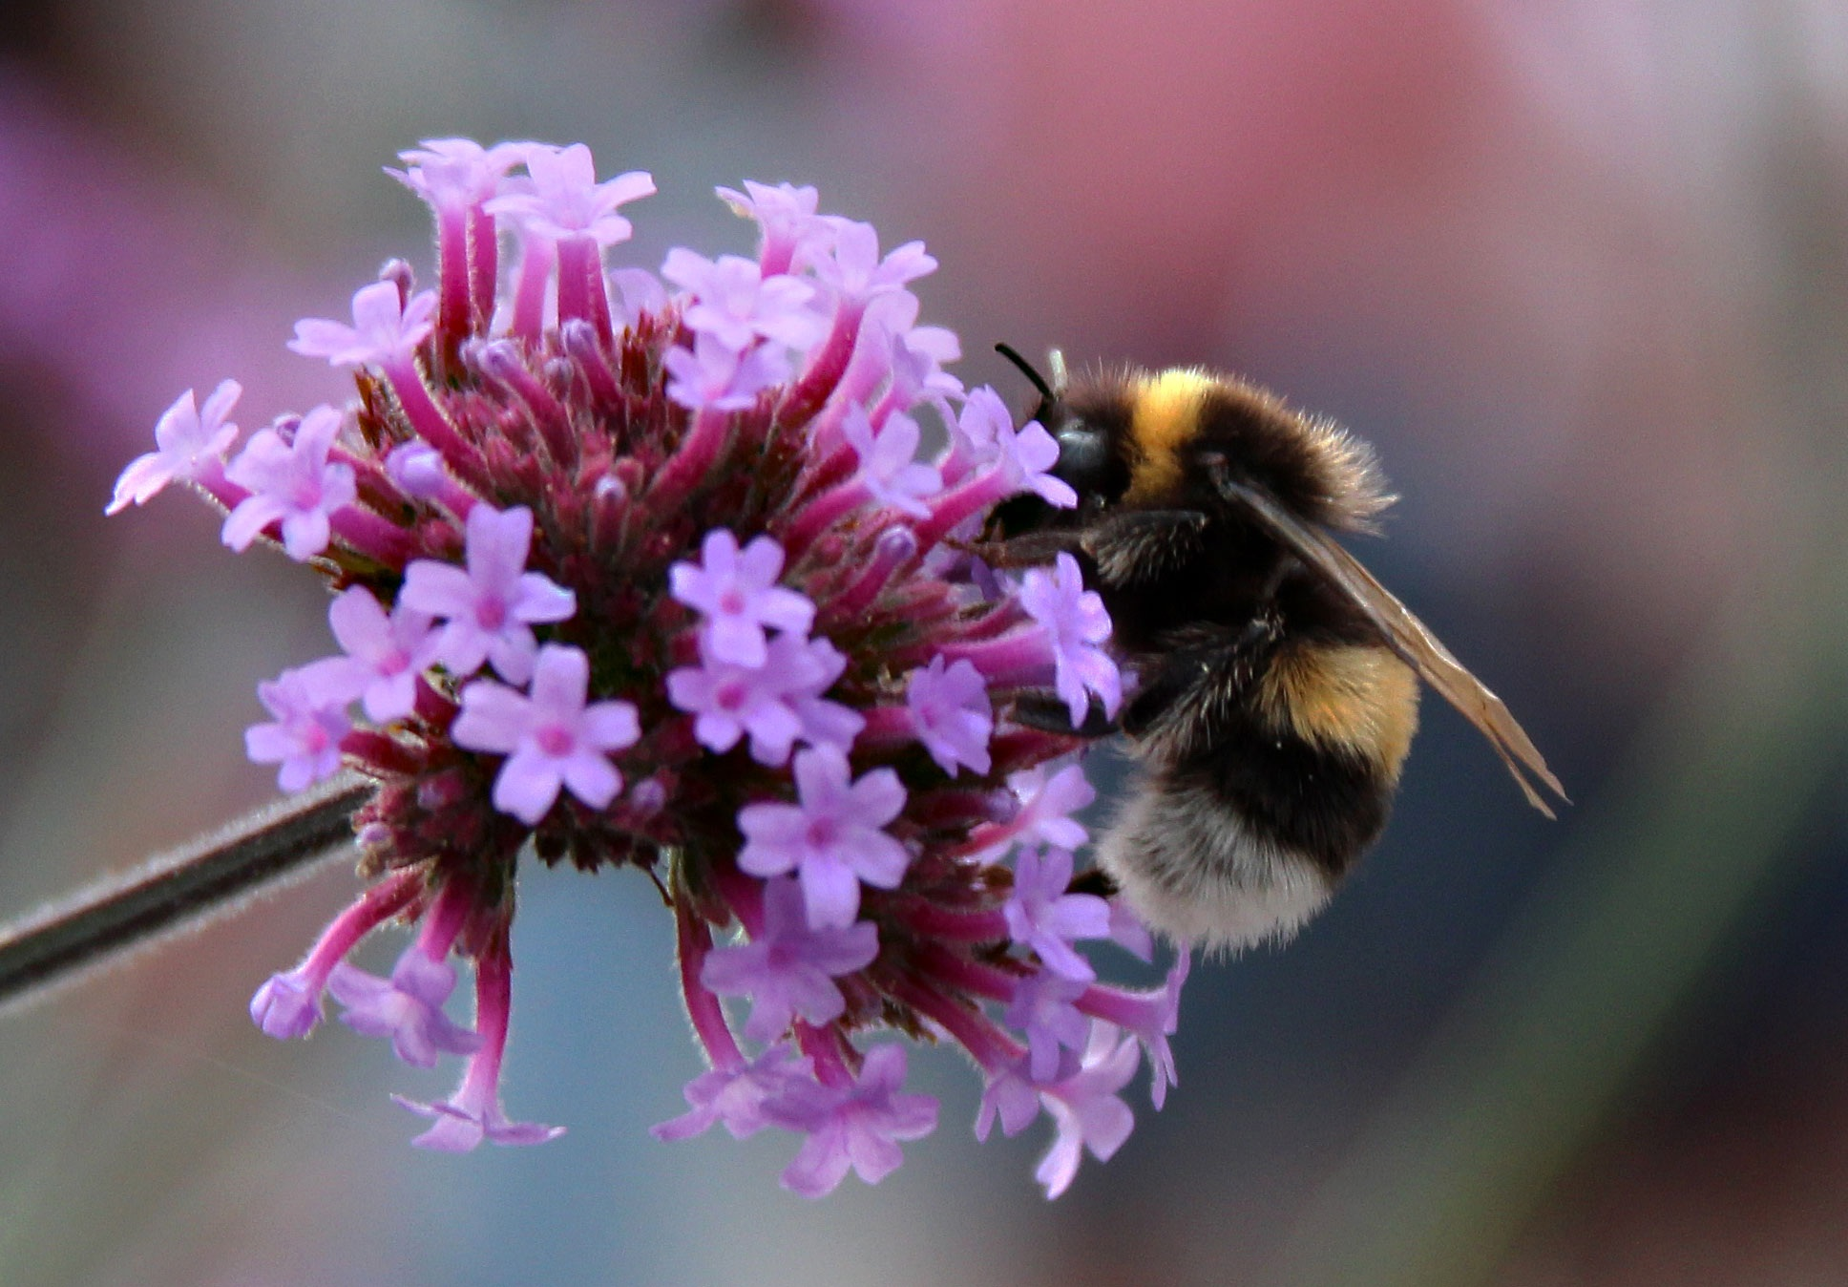
Shernhall Pre-School Summer term newsletter
April 2023 part 1
We hope you had a lovely Easter break. We would like to welcome you all back to pre-school and to say hello to our new families who have joined us for the summer term. We hope that the sun will shine on us.

Ofsted inspection

We were very pleased to have maintained our ‘Good’ rating during our inspection in February. The inspector was very pleased with what they saw and said, “Staff value each child and have high expectations of them”. “The curriculum is broad and interesting”. “Staff regard children’s safety as paramount”. Thank you to those parents who spoke to the inspector during their visit.

Safeguarding
Change of contact details, please keep your contact details up to date. If we need to contact you in an emergency and your details are not correct we will call your emergncey contacts.
Pick ups - If you have arranged for another person to pick up your child, please can you let us know in advance. You must give them the password before they come to collect your child. We will not let your child leave if we do not have the correct password and we will call you if we are unsure of anything.
Attendance - Illness and time off
If your child has vomitted or has had diarrhoea, our policy states that they cannot attend pre-school for 48 hours after the last bout of illness. Please do not send your child if they have a temperature and be aware that we do not give calpol, nurofen or antibiotics. If your child is unwell and is not able to take part in our normal pre-school activities they should not come in. If your child has an appointment please let us know that they will not be in. If your child is in receipt of funding from the borough for their place at Shernhall Pre-School it is vital that they attend regularly. Failure to do so without giving a valid reason and without notifying us may result in your child losing their place on the register. If you have a holiday planned, please ask your child’s key person for a holiday form. If you are paying for fees, please note that if your child is absent for any reason, fees are still payable in full. We do not swap sessions if your child has been off. If you have not notified us that your child will not be in, we will call parents listed as a contact to ask why they have not been brought to pre-school.
Reception places for September 2023
You should soon be informed by the local authority, which school your child will be attending for reception in September. You will have received a transition form from us before the Easter holiday. If you have not yet returned it to us, please can you do so as soon as possible. This will enable us to share your child’s progress report with their new school. You will also receive a copy to keep, and we hold a copy at pre-school. If you do not return it to us, we will not be able to share your child’s information and report with their new school. The deadline is Friday 23rd of June.
Declaration Forms and Funding
If your child is now eligible for a funded place, either 2yr or 3yr, you will be required to complete a declaration form so that we can claim funding from the borough. We will also require a new declaration form if you have increased or decreased your child’s funded hours. Please ask Pam in the office.
30 Hours funding for working families
If your child is in receipt of 30 hours funding, please can you ensure that your details are re submitted when you receive your reminder from Childcare Choices. We will not be able to claim your 30 hours funding if you are out of your ‘grace period’. If your child will be here with us for the next academic year and they turn 3 during the summer term or in the holiday you can apply for 30 hours funding from Childcare Choices. The funding for eligible children takes effect the term after the child turns 3. If you would like to apply, please note that you must apply before the 31st of August. Ideally you should apply during the summer term and let us know, then we can validate your code and reserve your 30-hour place for your child on the register.
Please go to www.childcarechoices.gov.uk for more information about 30 hours funding. If you have any questions, please feel free to come and speak to Pam in the office.

Invoices
If you have any outstanding payments from last term, please can you make payments as soon as possible. Unpaid fees have a huge impact on us as a small charity and effect our ability to plan for the future of the pre-school. If you can longer afford to pay fees for the hours your child attends, please come and speak to us about reducing your hours. Please can you ensure that you clear your monthly balance as invoices are given each month and not termly.
Reducing your sessions
If you no longer require your additional sessions this term, please can you let us know as soon as possible and give us at least 2 weeks’ notice.
Snacks
You will receive your snack invoice at the start of this term for the whole term up until 19th of July. We charge 30p per session to help us cover the costs of the snacks that we buy for the children. The funding we receive from the borough does not cover the amount we spend on the snacks we provide nor the staff’s time to prepare and serve the children. We therefore ask for your help. Full time children will have 124 snacks with us over the summer term. We provide a wide variety of fresh and healthy snacks for the children in every session. We also provide water and milk to children at no cost.
Felix project
We will continue to receive deliveries from the Felix Project each Monday afternoon. We don’t know what we will receive until the day so we cannot let you know in advance. Please bring a carrier bag and help yourself. They offer their service to charities, community groups and schools across the 32 Boroughs of London and reach 260,000 people every week.
Housekeeping
Please apply sun cream if needed before your child starts for the day. We also ask that your child brings a sun hat. We no not allow open toed sandals at pre-school and prefer that children wear appropriate footware and socks to keep their feet safe in a classroom environment.
Please can we ask that children are not brought into pre-school while still eating.
Please do not allow your child to bring in toys from home as they could be lost or damaged and they can cause other children to become upset.
Ensure names are written in clothes, shoes, changing bags and lunch bags.
No carrier bags to be brought into pre-school. Children should have separate lunch bags and changing bags.
We cannot keep buggies and scooters at the pre-school.
Please ensure that your child’s changing bag has enough nappies, wipes and clothes for the week. We will remind you when it needs to be topped up.
Packed lunches
We encourage children to eat healthily while they are with us. Packed lunches should be healthy and must not contain chocolate, crisps, fizzy drinks or nuts, this includes NUTELLA SPREAD AND PEANUT BUTTER. We do not allow nuts of any kind at pre-school due to children’s allergies. Please speak to us if you have any questions. Please remember to cut grapes lengthways and cherry tomatoes and olives in half. No glass containers jars or bottles to be brought into pre-school. Can we also ask that use by dates are checked for lunchbox items, especially yoghurts and that lunch boxes and drink bottles have your child’s name on them and that you include a cool pack as we cannot refrigerate lunches. Where possible, we will leave any uneaten items in your child’s lunchbox so you will be able to see what they have eaten.
Punctuality
We are aware that parents have other children to drop off and pick up at local schools but we ask that if this is not the case that you adhere to our session times.
Early Years Pupil Premium
The funding we receive for Early Years Pupil Premium will increase to 62 pence per hour from the summer term. This is paid directly to us for eligible 3-year-olds the term after they turn 3. EYPP payments for the summer term will give us an extra £115.32 per child if attending for 15 funded hours. This extra money is used for enrichment activities such as paying for theatre company visits and animal workshops. All we need is your National Insurance Number to enter on the LBWF funding portal. You may have already included this information on your declaration form. If you don’t think you have, please give this information to Pam in the office.

Rah Rah Theatre Company
We have booked the Rah Rah theatre company to come in and visit us on Wednesday 24th of May. They will be performing the Teddy Bear’s Picnic story and will be here all day so children in both the morning and afternoon sessions will see the show. We would like to invite our parents too. If your child does not normally attend on Wednesday you are welcome bring them and stay with them for the afternoon performance at 1.30pm. Children who are not on our register on Wednesday will not be covered by our staff ratio.
Pre-School photographs
We are happy to tell you that Tempest Photography will be back to photograph the children this term. They will be visiting on Friday 26th of May. We will be inviting parents who would like to have a photograph taken with siblings to come into pre-school from 8.15am. If your child does not attend on Friday, you are also welcome to come at this time. The photographer will see you on a first come first served basis. All other children will be photographed during their normal session. You will be given a proof of the photograph taken on the day and you can then order your choice of photographs online direct from Tempest. We will not be taking any money or orders for photographs.
Half term holiday
We will finish this half term on Friday 26th of May. We will return to pre-school on Monday 5th of June.
We also have the May day bank holiday on Monday 1st of May and also Monday 8th of May for Charles III’s coronation when we will be closed.
Budget announcement
You may be aware of the recent budget announcements made by the government regarding funding for working parents which will take effect from April 2024. We will be able to give you more information when the details of the offer and funding has been finalised by the local authority.
Fee increases for new academic year
We are working on our budget for the new academic year from September. We may have to increase our fees. We will of course keep you updated.

Topics for the summer term

Half term 1
Music and dance from around the world Dinosaurs Shapes
Receycling Week Opposites Camping

Half Term 2
Child Safety Week Healthy Eating Week Under the Sea
Countries and Cultures Transport and Travel
Getting ready for school Transition

Dates for your Diary
Friday/Saturday 21/22 - April Eid Al Fitr
23rd April St George’s Day
Monday 1st of May closed for May Day bank holiday
Saturday 6th of May King Charles III coronation
Monday 8th of May closed for King Charles III coronation bank holiday
Mental Health Awareness week 15th-21st May
Walk to school Week 15th-19th May
Rah Rah Theatre Company visit to perform Teddy Bear’s picnic 24th May
Tempest Photography 26th May
Half Term 29th May – 2nd of June
Child Safety Week 5th - 11th June
Healthy Eating Week 12th - 16th June
Trip to village shops Date tbc
Father’s Day 18th June
Rainbow Week 19th – 23rd June
Bake sale 26th - 30th June Date tbc
Zoolab workshop 29th June
Sports Day 6th July
Graduation party
Last day of term and party 19th July 10am to 1pm - No normal session
More information TBC
New academic year 23-24 starts on Wednesday 6th of September
Many thanks, Shernhall Pre-School. 17/03/2023

